To acces to menuconfig
Open ESP-IDF CMD 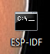
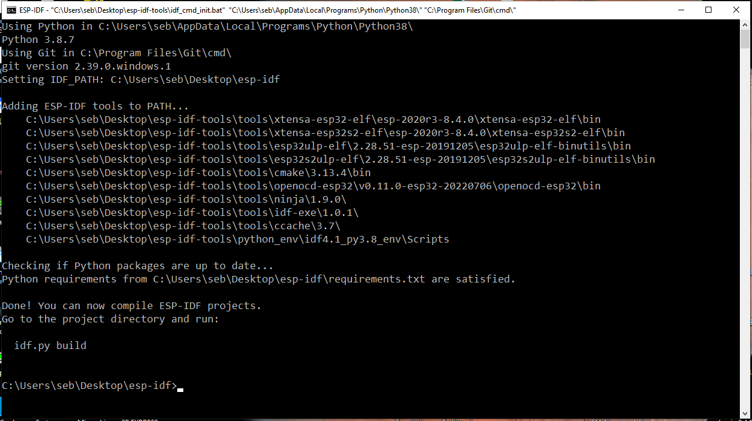
Now go to your project folder
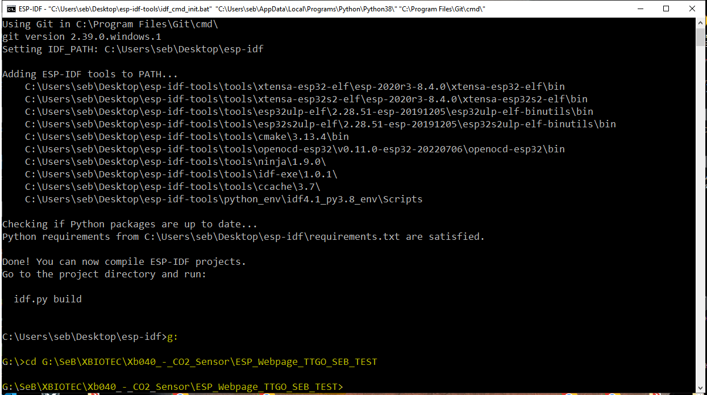
Now type idf.py menuconfig
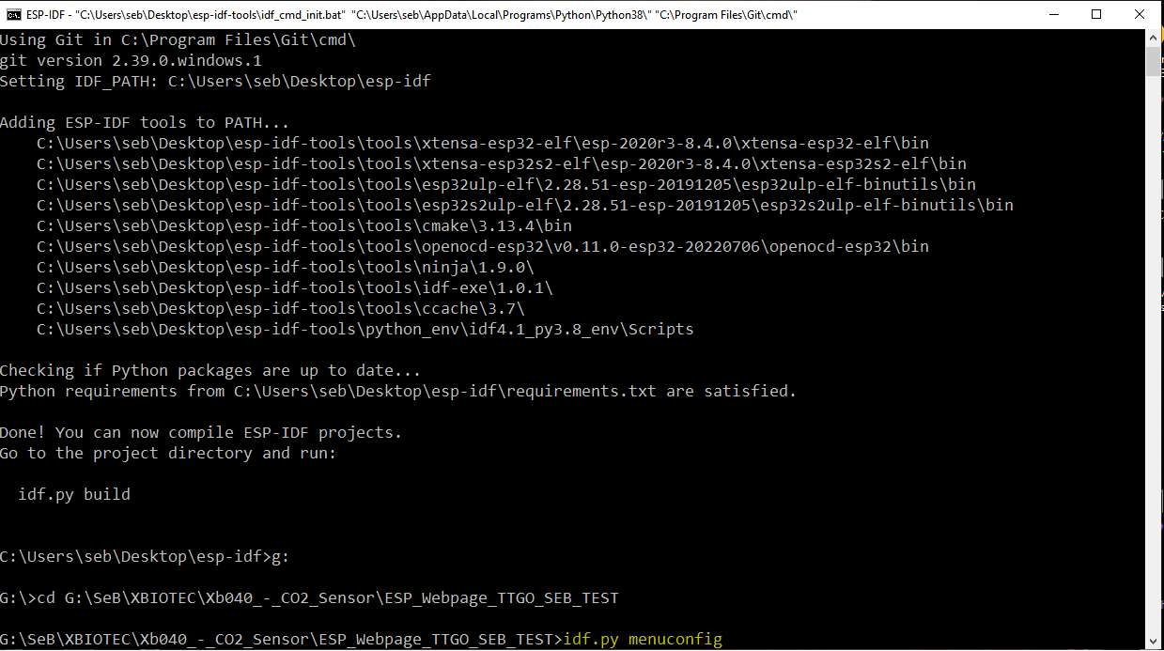
Enter
Navigate to COMPONENT CONFIG then Enter
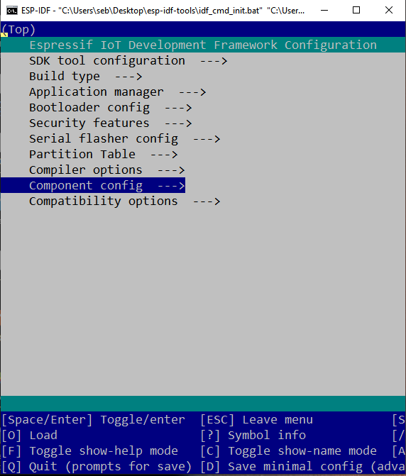
Then LWIP enter
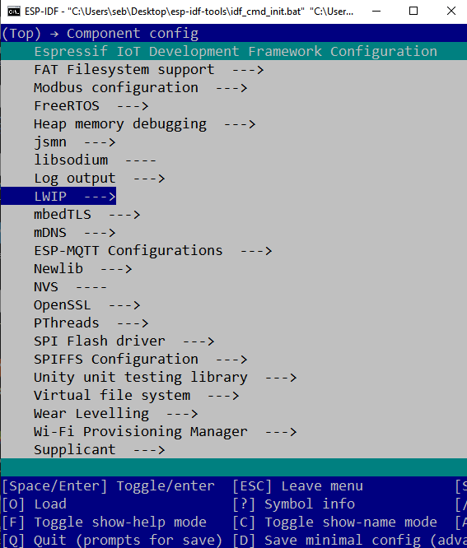

Then Local Netif hostname Enter
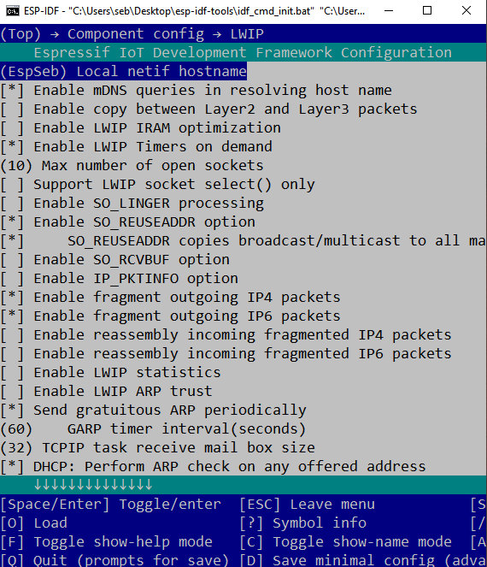
Now you can change the hostname
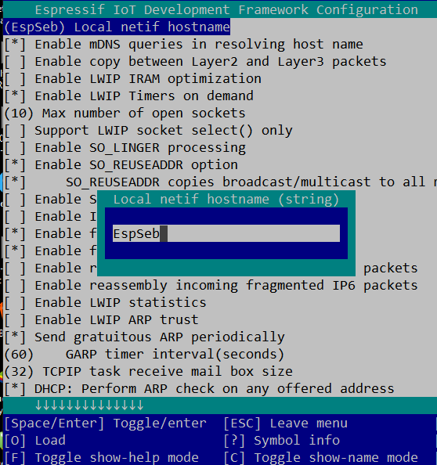
Escape and save
Recompile on FC


