FC8 run Modbus master - USB to Nano Slave
This is not a tutorial for biginner.
It is a quick guide for setting up the PC run FC8 Modbus Master-Slave communication program (software to hardware over USB).
Please have a look at FC8 files and change settings to your need.
PS
I hope this will help to some users to setup two Modbus devices.
https://www.matrixtsl.com/mmforums/viewtopic.php?f=76&t=22400
To run this project you need to have the:
Installed FC8
Two files
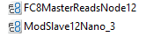
Arduino (Uno or Nano) one board (I used Nano for this project).
Communication modules: Max 485 and Rs485 to USB.
Connection wires, etc.
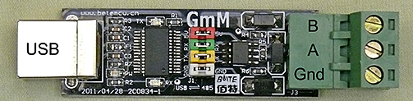
The Arduino Slave hardware setup
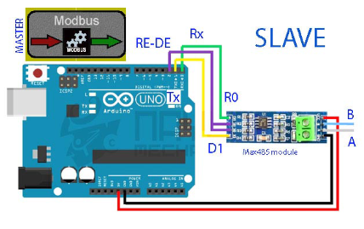
Program Arduino by loading file 'ModSlave12Nano_3' into FC8 and making HEX file.

1. Connect USB-to-RS485 Module to Arduino and PC.
2. Check the Port N.
3. Run Modbus Master file on FC8
Note: Modbus Master uses the port 6 (in my case)
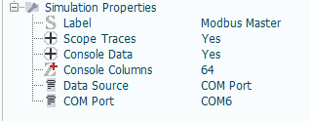

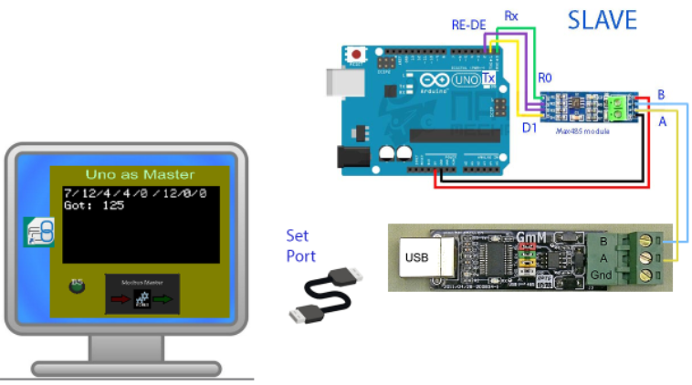

Flashing lights on Max and Rs485 modules show the communication state.
A quick video shows the major points of this example.
Youtube:
https://youtu.be/8MCOl0FchPw

